**CBMC**

Team Lead – Divyanshu Shrivastava

**Team –**

|  |  |  |
| --- | --- | --- |
| 1 | Divyanshu Shrivastava | 187909 |
| 2 | Ekta Singh Parmar | 187910 |
| 3 | Ravi Mandoriya | 187928 |
| 4 | Sonali Mandloi | 187936 |
| 5 | Sumit Sisodiya | 187938 |
| 6 | Tanvi Chalisgaonkar | 187943 |
| 7 | Vandita Patel | 187944 |

**cbmc test1**

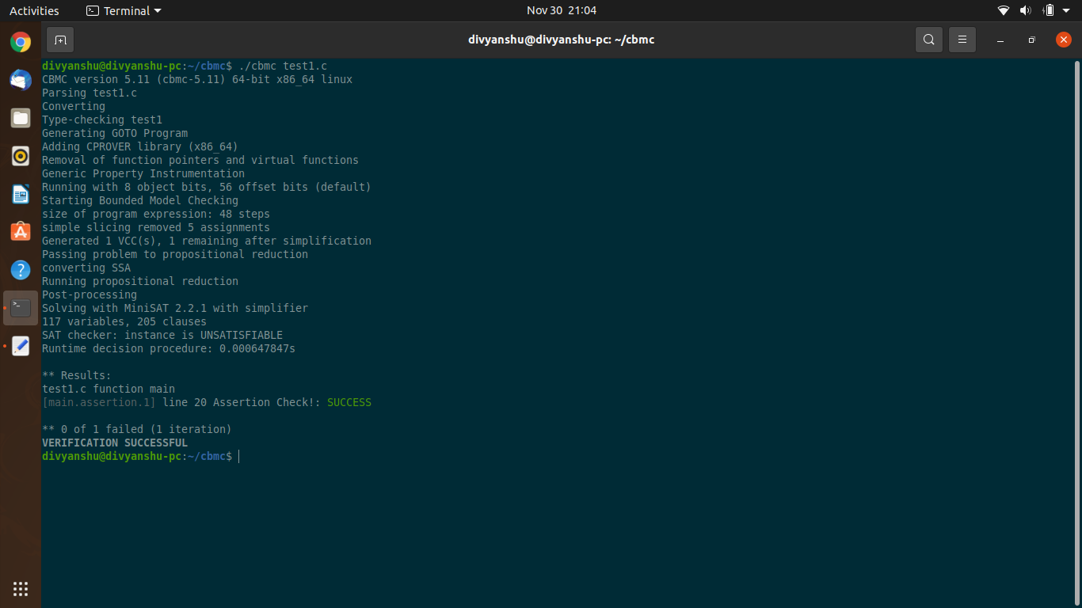

**cbmc test2**

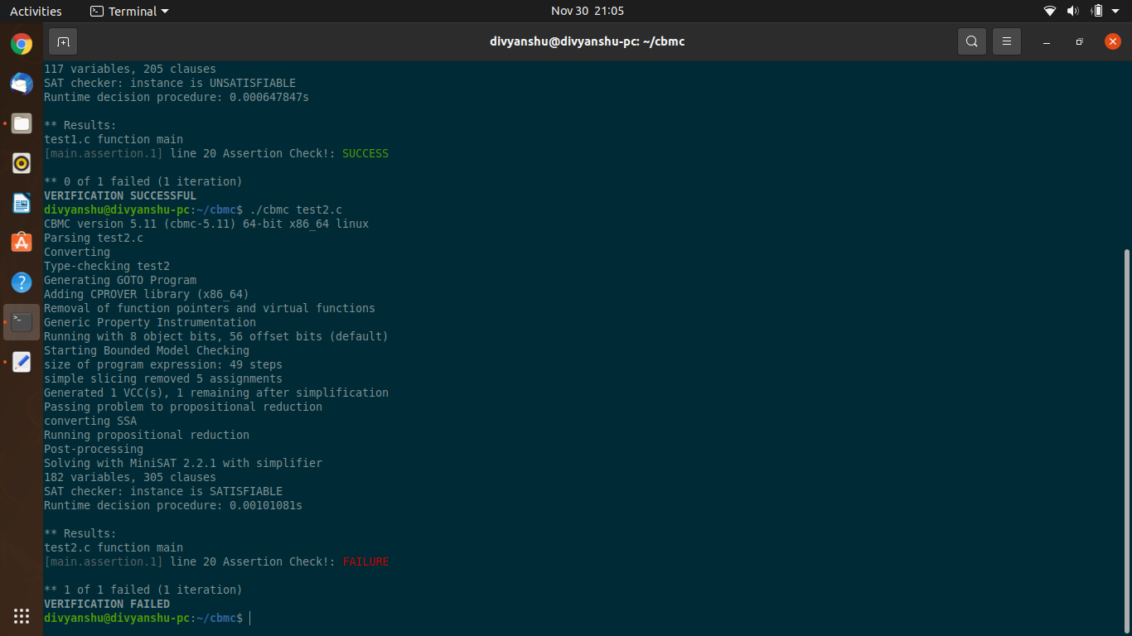

**Loop**

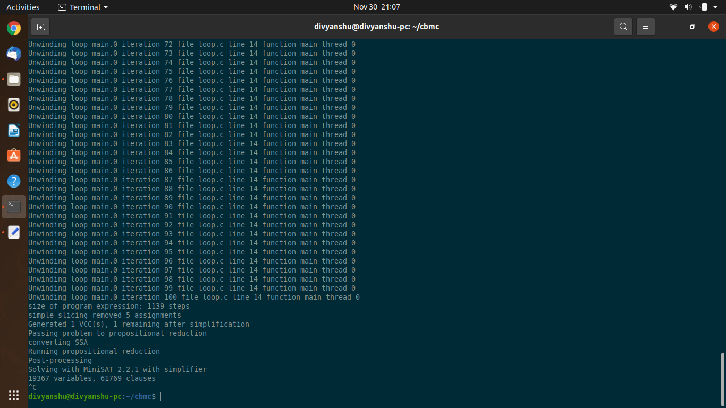

**unwind 100 loop**

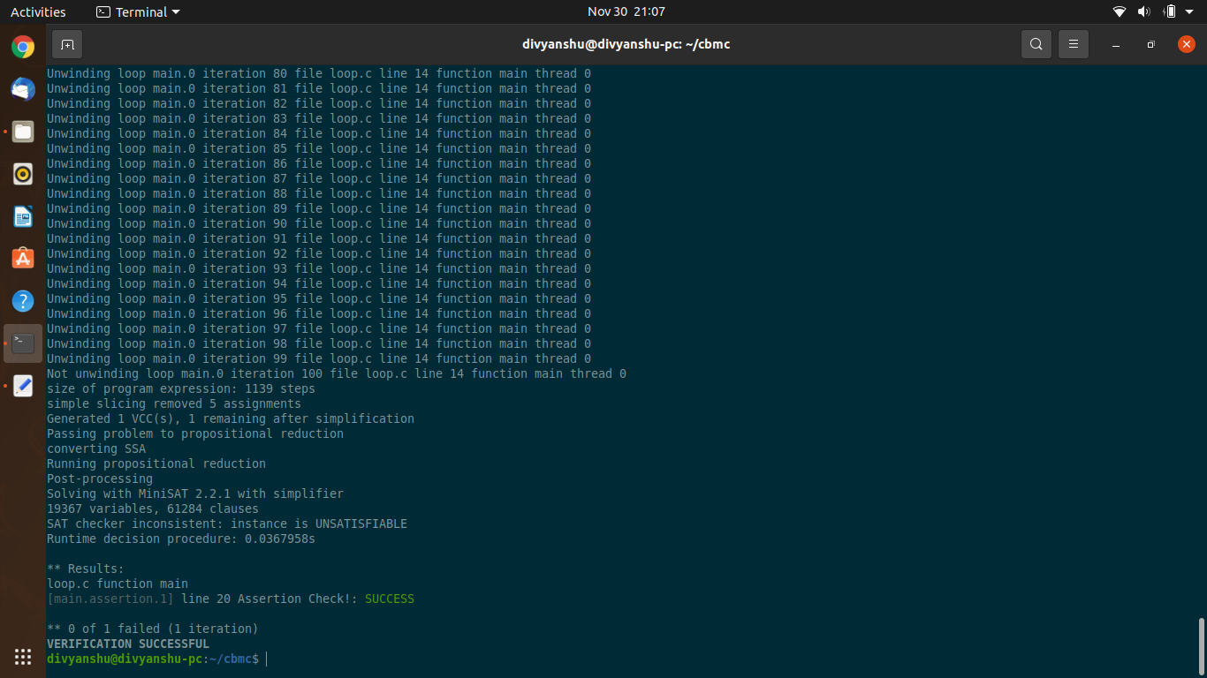

**unwind 100 statemate**

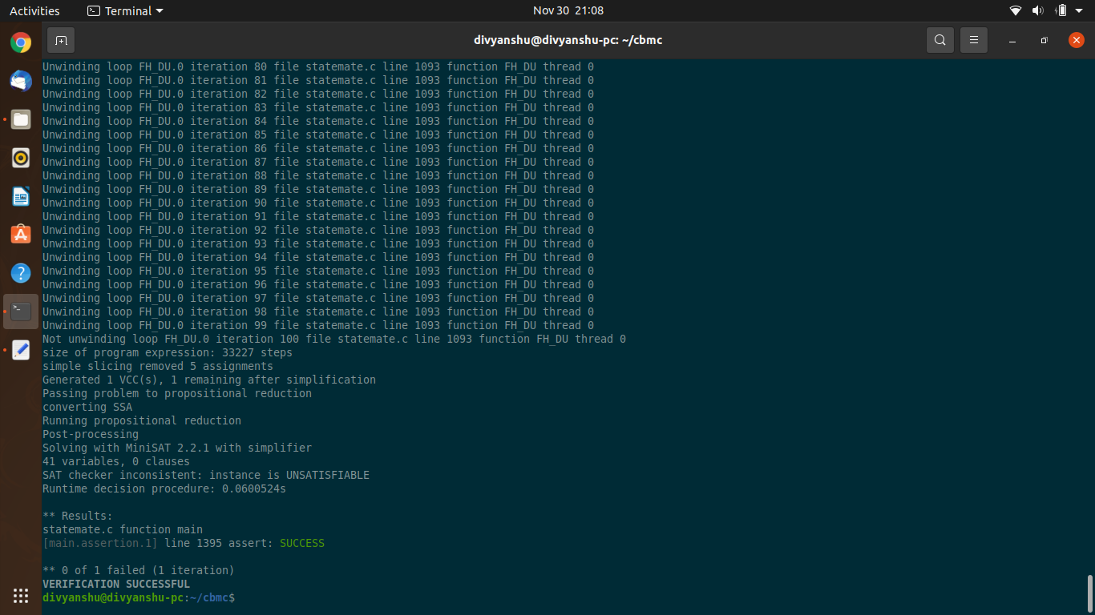

**unwind 1001 statemate**

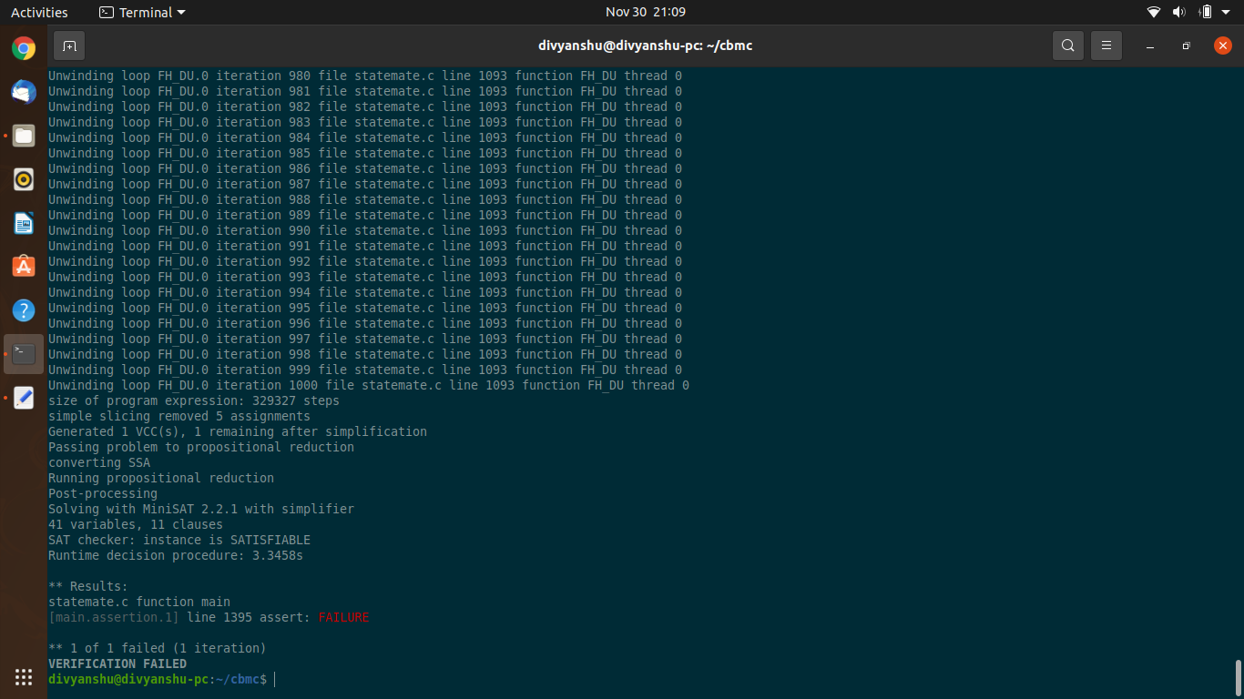

**cbmc sumsubset**

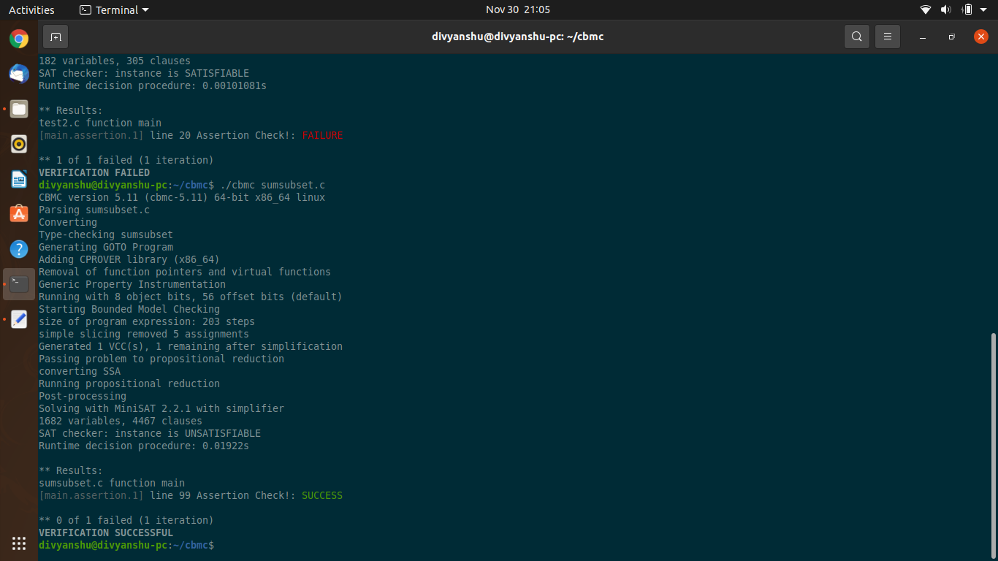

**cbmc sumsubset2**

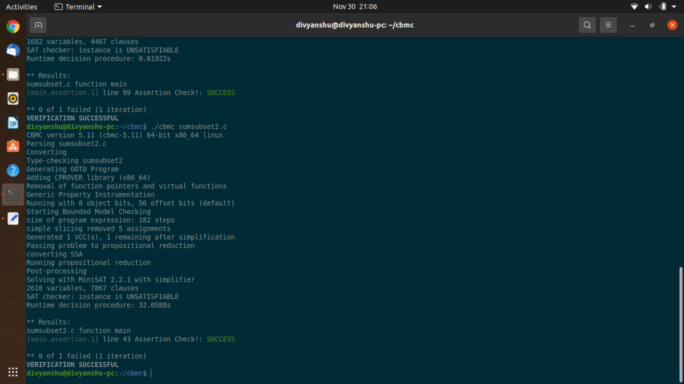

**cbmc sumsubset3**

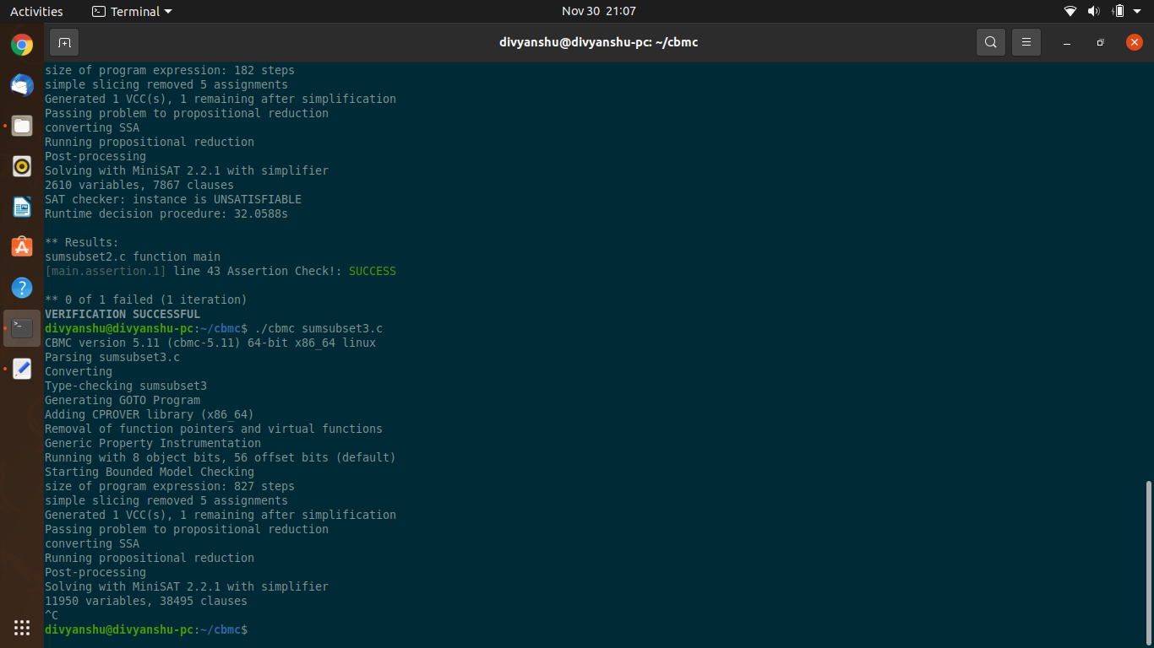

**cover branch test14**

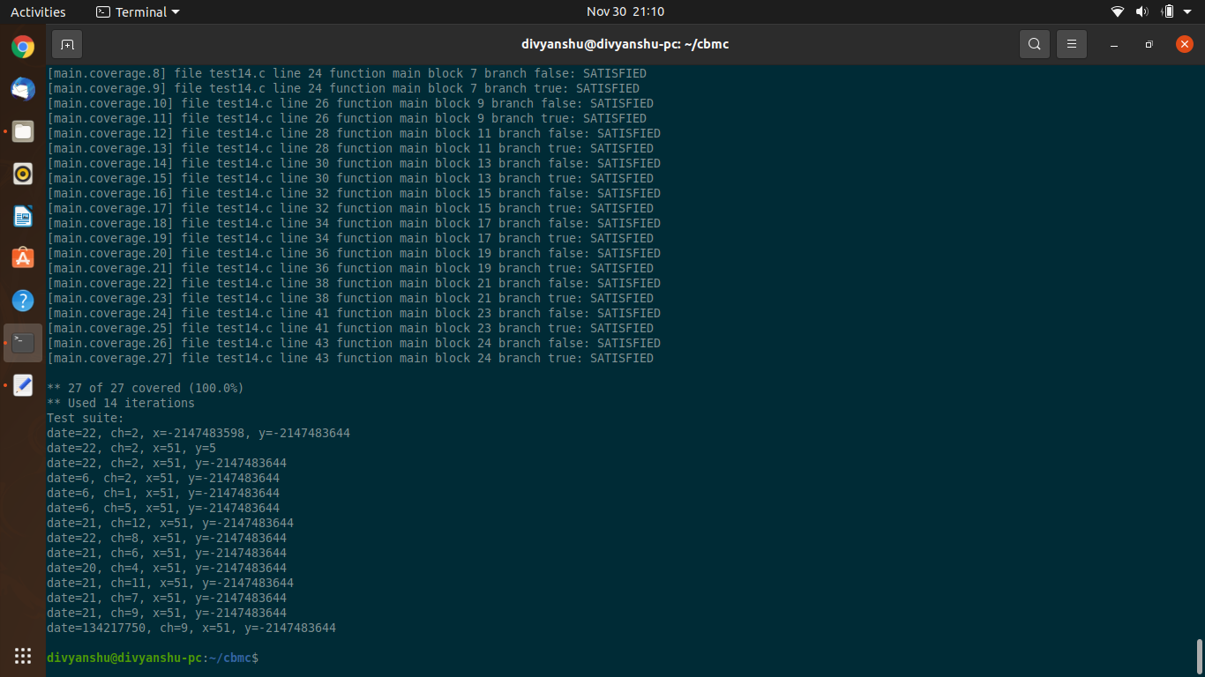

**cover condition test14**

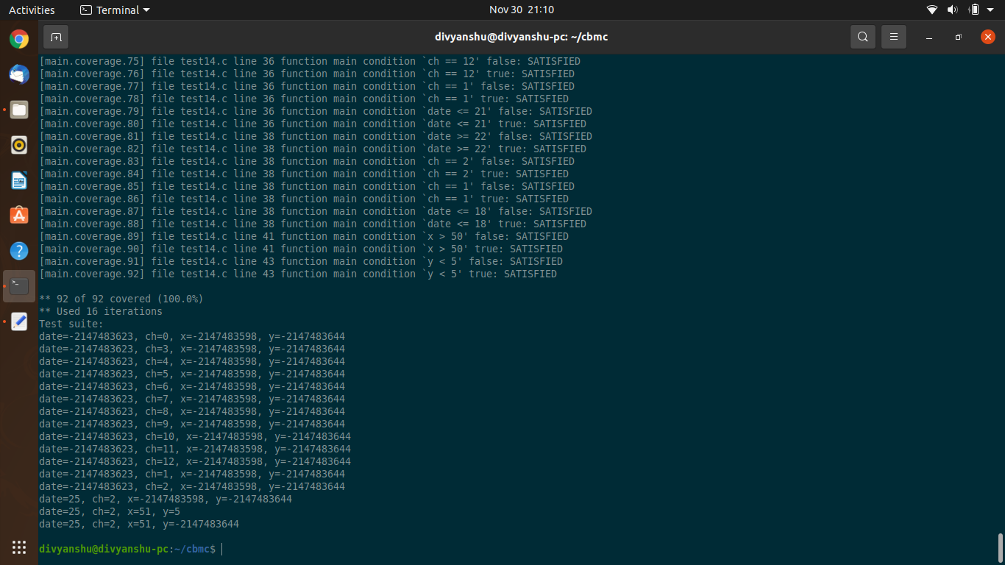

**cover decision test14**

